
Observer Report
Created on Tuesday, 18 April 2023 4:32:58 PM
Production Information
Shotpoints Acquired Today
1016
Aborted Shots/Sweeps
0
First Shot
18/04/2023 8:11:13 AM UTC +10 hours
Last Shot
18/04/2023 4:18:05 PM UTC +10 hours
Production Time
8 hours 6 minutes
Total Acquired
5197
Planned Shots
5653
Remaining Shots
456
Today's Acquisition Speed
125 Shotpoints/Hour
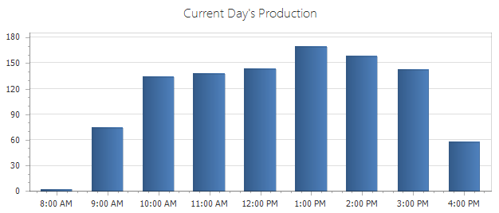
Production
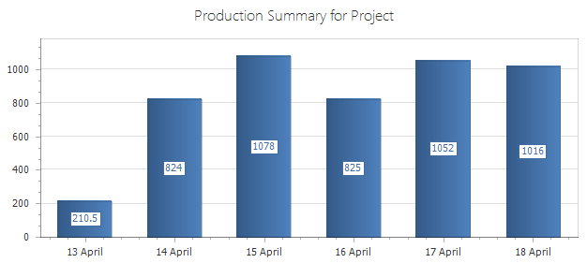
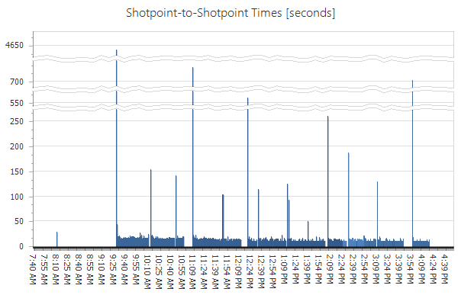
Overhead and Downtime
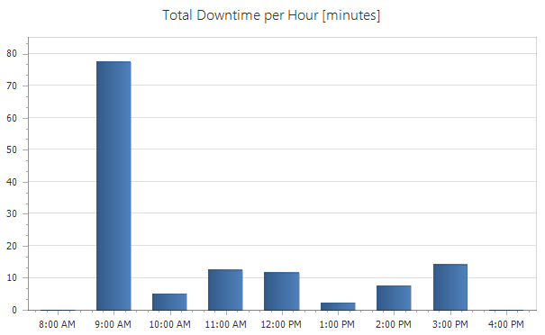
Area Map
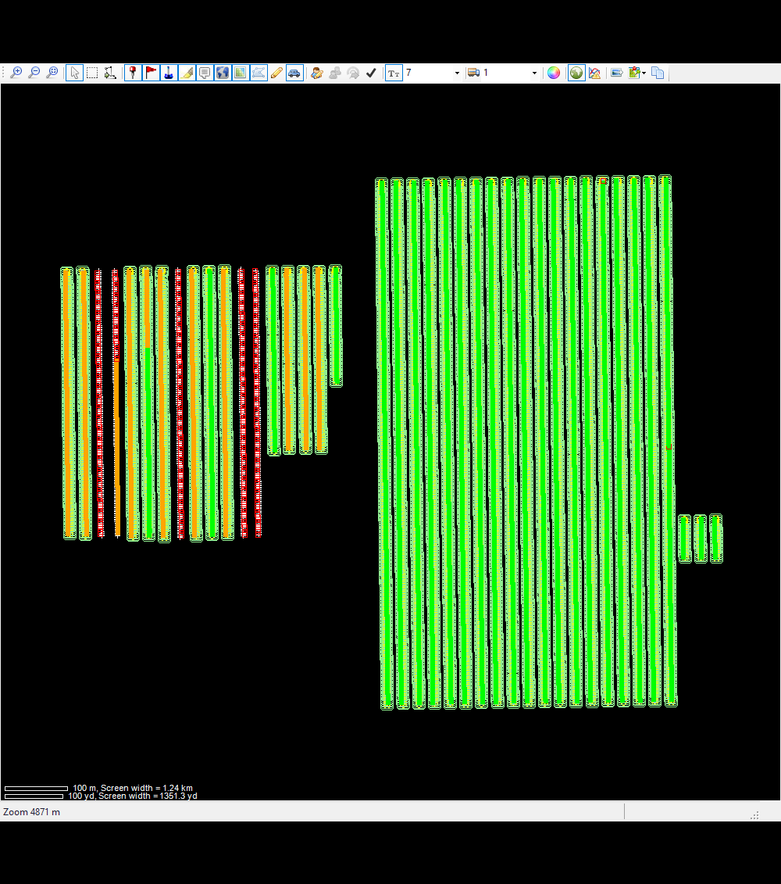
List of Source Decoders
Group
Unit
Type
Driver/Shooter
1
7
Force Three

Vibrator Error Summary
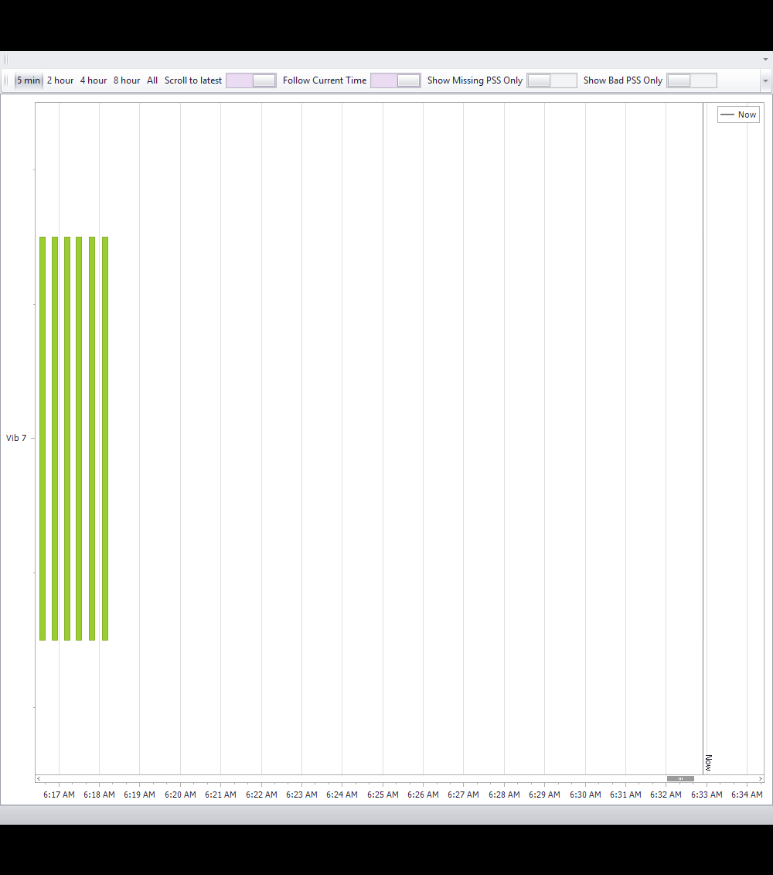
Vibrator PSS Information
PSS Geographical Representation
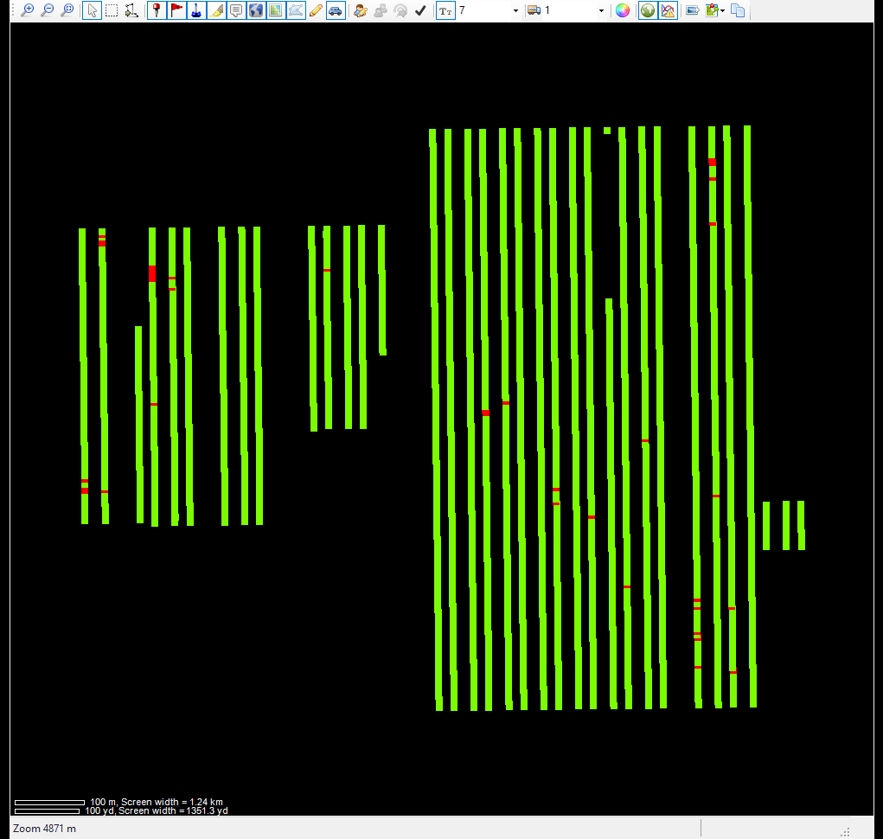
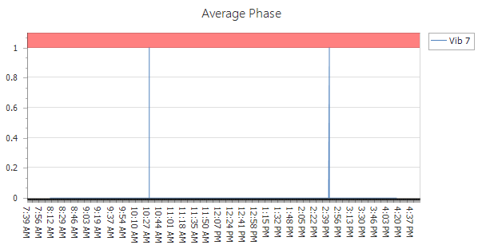
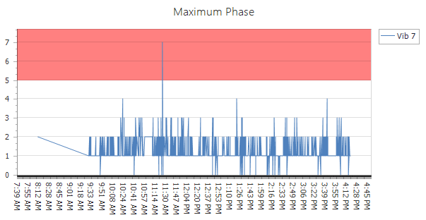
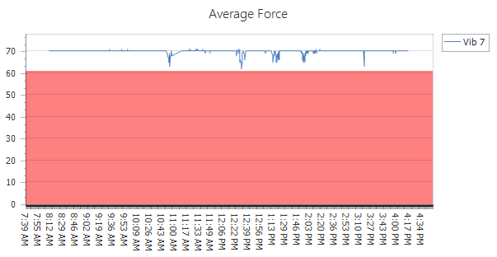
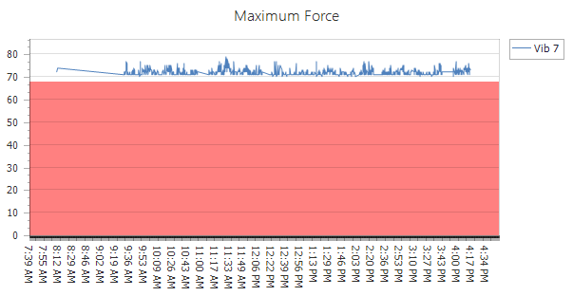
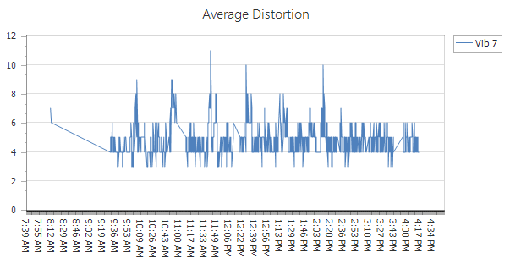
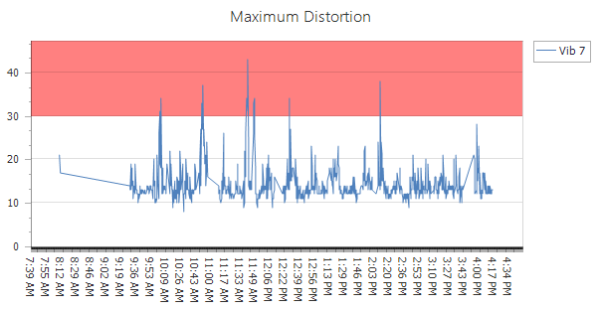
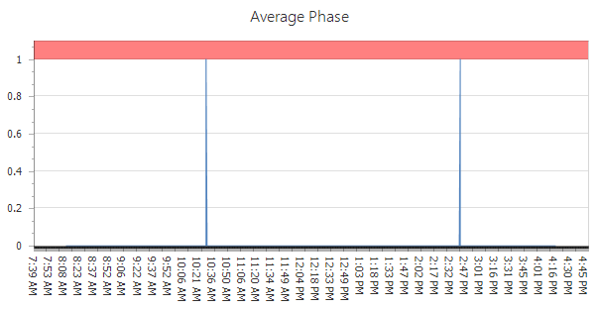
7
Vibrator
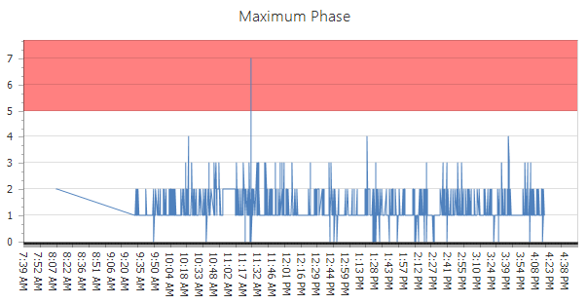
Phase Plots
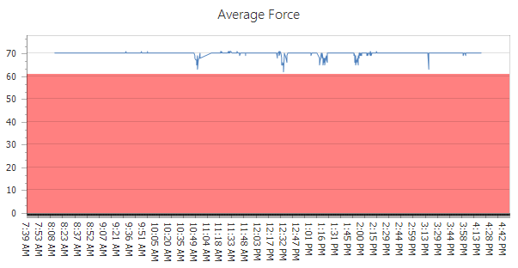
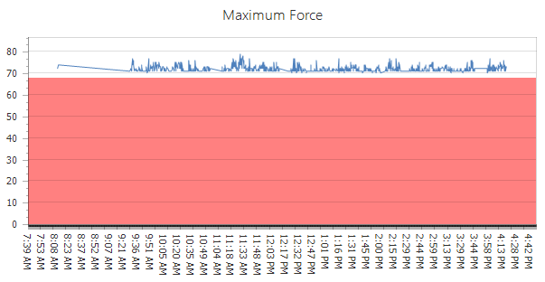
Force Plots
7
Vibrator
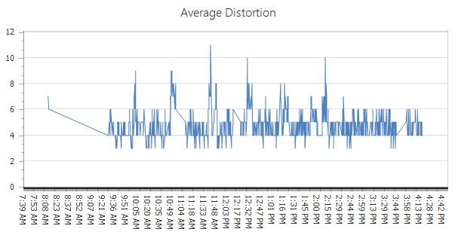
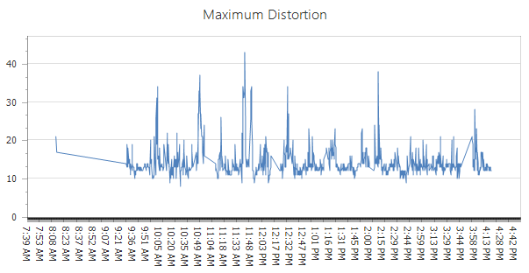
Vibrator
7
Distortion Plots

